Proof of Concept Scope Statement

Invoice Management

Rossum Invoice Extraction and Invoice QR Code Extraction Data

fed to

Project Code Validation of Invoices

Contents

1. Introduction 3
2. Current Business Process 3
2.1. Invoice Processing 3
2.2. Process Time 4
3. Scope 4
3.1. Success Criteria 4
3.2. Out of Scope 5
3.3. Time Line 5
4. Specific Requirement 5
4.1. NDA 5
4.2. Data 5
4.3. Access Control 5
4.4. POC Type 5
4.5. Hardware and Software Requirements 5
Hardware 5
Software 7
5. POC Sign-Off 7

Introduction

The purpose of this document is to define scope of a Proof of Concept (POC) around the Use-Case of Invoice Data Extraction using Rossum and a QR Code Utility which is fed to the Project Code for Validation of Invoice Data from the perspective of demonstrating feasibility of using Rossum, Project Code and QR Code Utility.

Current Business Process

Invoice Processing

Invoice Compliancy Processing in Laserfische is a manual effort where the extracted Metadata of the Invoice Fields is manually compared to the Invoice Documents for further processing it in the Seller Portal. Not all fields are successfully extracted from the Invoices.

Invoice Compliancy Processing is a frequent activity for users at Invoice Metadata Management by Laserfiche , which happens as and when new invoices arrive from Fullfillment Center(FC) to Laserfiche.
The current procedure is as follows:
- Fulfilment Centre(FC)/Drag and Drop Incoming Invoices to Laserfiche:
- The incoming invoices are received at Laserfiche either from Fulfilment Centre or by Drag and drop.

- Extraction of Metadata by Laserfiche:
  - The invoices pertaining to a specific seller is opened in Laserfiche by a user assigned to the ‘New Scan’ Folder in the Laserfiche folder structure.
  - Laserfiche shows the Metadata of the selected invoice in the ‘New Scan’ folder.
  - The invoice detail must be entered into the Metadata manually for the missing, not clear and incorrect fields.

- Invoice Compliancy Check:
  - Prior to Metadata update, the invoice should be pre-validated to meet the compliance criteria.
  - This pre-validation is done manually for the compliancy checks.
  - The incorrect, not clear or missing data the invoices are rejected at the Metadata level of the Laserfiche or further clarification by email from vendor.

Process Time

Sr.No | Tasks | Time Taken
 | Invoice Compliancy Check
1 | Checking the mandatory 23 fields of the Invoice  Against the invoice document | 10 - 15 minutes per scanned invoice
2 | Filling the missing, incorrect or not clear fields | 10 minutes per scanned invoice
3 | Setting the status of the Invoice in Laserfiche | 2 minutes

Scope
The focus of this PoC will be automating Extraction of Invoice by Rossum and Extraction of Data from QR Code from the invoices and Validations of the GSTIN Compliancy Check of the Invoice details in Project Code.
PoC is implemented for the purpose of demonstrating Rossum, QR Code Utility and Project Code, practical applicability in achieving a higher rate of extraction of fields in unclear cases of the current invoice extraction cases. The solution is not developed for operational purposes.

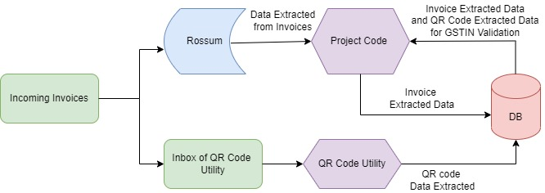

Success Criteria
The POC is deemed successful upon demonstration of Complete Automation of a Invoice Extraction by Rossum and QR Code Data Extraction from Invoices and Validation of GSTIN Compliancy checks of Invoice by Project Code.
No Manual Steps are required in any of the above processes.

Out of Scope
- Multiple Seller invoices processing
- Update to Laserfiche Metadata.
- All field Validations in Project Code.

Time Line

Day-1 & 2 |  | Day-3 - 9 |  | Day-10
Understand Business Requirement
Design Process
 |  | POC Documentation & Review
 |  |  |  | Final Presentation

Specific Requirement

NDA
NDA to be signed

Data
Process will have access to client invoices; not production or current data.
Process will have Access to the applications mentioned below.

Access Control
Access to applications mentioned above will be provided using temporary user credentials.
Access to all these systems will be through a dedicated machine on which Rossum access, Project Code and QR Code utility will be installed.

POC Type
Pierien engineers will implement PoC.

Hardware and Software Requirements

Hardware
 | Minimum | Recommended
CPU | 1.4GHz 32-bit (x86) | Dual Core 1.8GHz 64-bit
RAM | 4 GB | 8 GB

Software

Project Code | Operating System | Python
Project Code | - Windows Server 2008/2012 R2/Windows Server 2016 | Minimum: 3.9

POC Sign-Off

- Once completed, an interactive session to demonstrate and review PoC outcome will be communicated.
- Deliverables :
    - Recorded video of process in action
    - POC scope document in action will be shared with the client

Reviewed and confirmed by
Date:

Place:
_______________________________

